For more instructions, see “Potty Training Instructions” found on the APMRT website: http://www.cla.auburn.edu/apmrt/foster-parents/

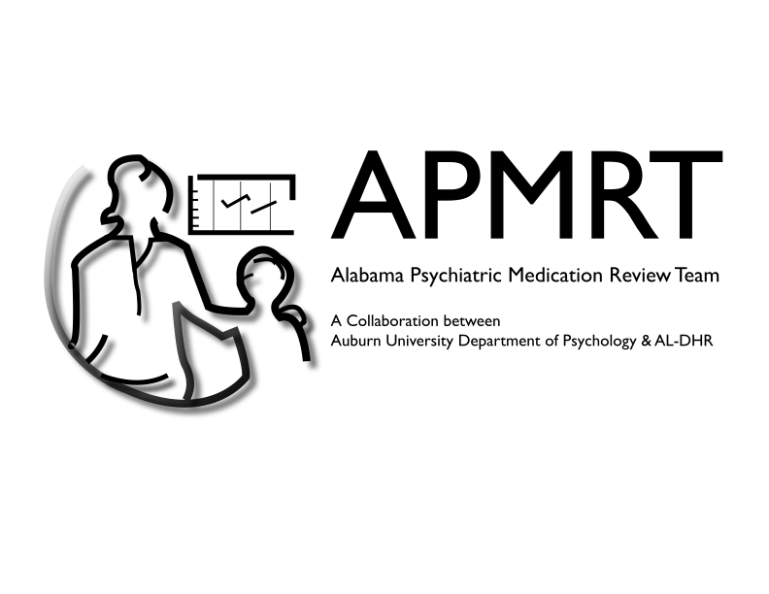

**What About Accidents?**

1. Immediately take to bathroom.
2. If they use toilet within a minute, treat as a success - potty party!
3. If they do not use toilet in 1 minute, pull up pants, return to accident location, firmly state “no wet pants,” go back to bathroom.
4. Have child change clothes as independently as possible.
5. Set the timer for the next potty visit.
6. When the timer goes off, take child to bathroom door.
7. (If the child independently asks to go potty before the timer goes off, praise them for asking, take them to the bathroom, and reset the timer.)
8. Ask child to say “potty,” “toilet,” “bathroom,” etc.
9. Praise child for asking for potty (e.g., “Nice job telling me you have to go to the bathroom!”).
10. Place child on toilet for 5 minutes and give child a fun item while sitting.
11. If child uses the toilet: throw a potty party! Tell the child they did a nice job using the potty and give them something they **REALLY LIKE** such as a piece of candy or favorite toy, and pull up pants.
12. If child does not use the toilet: remove the item, tell the child they did a nice job sitting on the toilet, and pull up pants.
13. Have child wash their hands.
14. Reset timer

If you are still having trouble with toilet training, contact the behavior analyst assigned to your child or visit <http://cla.auburn.edu/apmrt> for more contact information.

Rewards

* Favorite foods/drinks
* Special toys (iPad, Legos)
* Favorite activities (park, games)

**Potty Checklist**



Pieces to the Potty Puzzle



* Use regular underwear.
* Get your child to drink, drink, drink using favorite liquids.
* Place child on toilet at regular times.
* Give child favorite toy/activity while on the toilet.
* Give favorite rewards for using the toilet.