MEDICATION APPOINTMENT checklist
Appt Date: ____________
Doctor: _________________

Pre-Appointment
☐ Bring to the appointment: 1. Medication Appointment Worksheet (this document), 2. G/Y/R Graph and 3. Medication Review Letter

Medication & behavior UPDATEs
Discuss each of the following with the doctor:
☐ Other Services (e.g., counseling, behavioral):
- ______________________________________________________
☐ Side Effects of Concern:
- ______________________________________________________
☐ Discuss the Green/Yellow/Red Graph with the Doctor:
- “In the last ____ weeks, [insert child’s name] has had _____ green days and _____ red days.”
What behaviors have improved? | What behaviors have worsened?
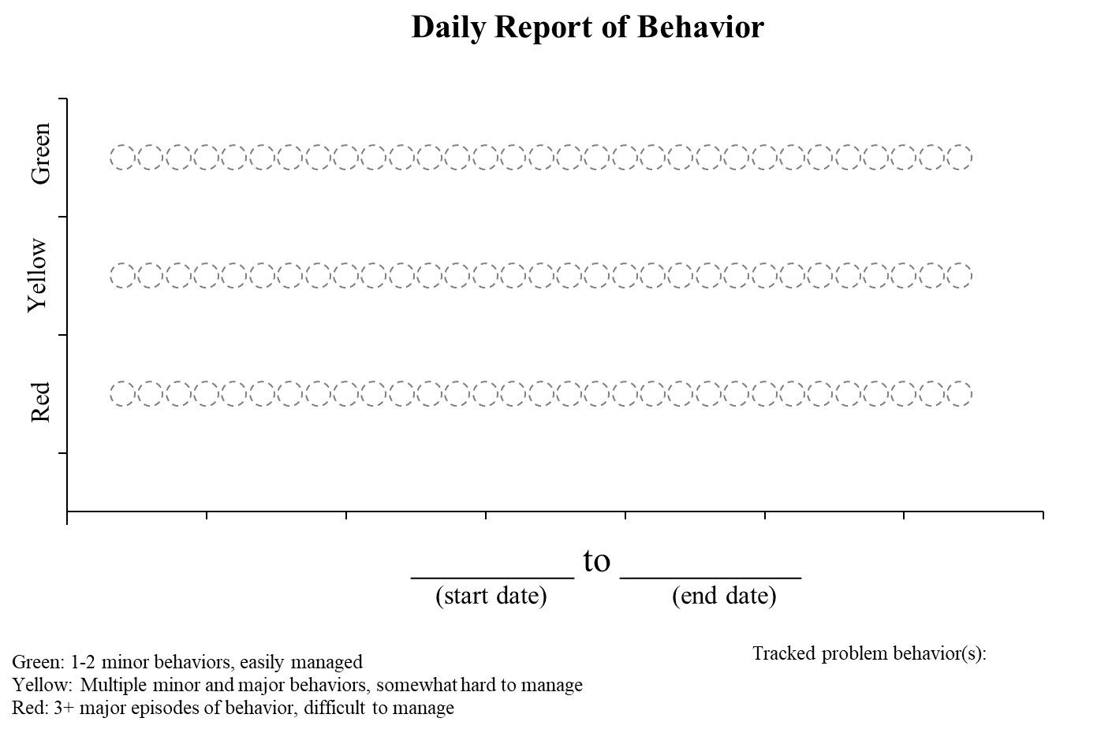
Green Days | 1 – 2 minor behaviors, easily managed, no major problem behavior
Yellow Days | multiple minor behaviors, somewhat hard to manage, and/or 1-2 major problem behaviors
Red Days | multiple minor behaviors, difficult to manage, and/or 3+ major episodes of behavior

APPOINTMENT WORKSHEET pg. 2

MEDICATION CHANGES
Target Medication 1: _______________________  Current Dose: ________, ______ times per day |  | Target Medication 2: _______________________  Current Dose: ________, ______ times per day
Target Symptoms: _____________________________  Over the last ____ weeks, these target symptoms have:  Increased Decreased Not Occurred  Maintained (Stayed the Same/No Change) |  | Target Symptoms: ______________________________  Over the last ____ weeks, these target symptoms have:  Increased Decreased Not Occurred  Maintained (Stayed the Same/No Change)
- "What behavior is this medication for?"
  - Medication 1: ___________________________________________________________________
  - Medication 2: ___________________________________________________________________
- "How long are we going to try this medication?"
  - Medication 1: ___________________________________________________________________
  - Medication 2: ___________________________________________________________________
- "What are possible side effects I should look out for?"
  - Medication 1: ___________________________________________________________________
  - Medication 2: ___________________________________________________________________
- "When would it be appropriate to try a period off of this medication?"
  - Medication 1: ___________________________________________________________________
  - Medication 2: ___________________________________________________________________
- "What behavior changes would you like to see before decreasing the dose or the amount of times (s)he takes it per day?" (if applicable)
  - Medication 1: ___________________________________________________________________
  - Medication 2: ___________________________________________________________________
Possible follow-up (Examples: if s(he) isn't in school, how can I evaluate if it's working? Can this medication interact with any other medications? Should s(he) be getting blood work while on this medication?):

NOTES:

____________________________________________________________________________________________________
____________________________________________________________________________________________________
____________________________________________________________________________________________________
____________________________________________________________________________________________________
____________________________________________________________________________________________________
____________________________________________________________________________________________________
____________________________________________________________________________________________________

