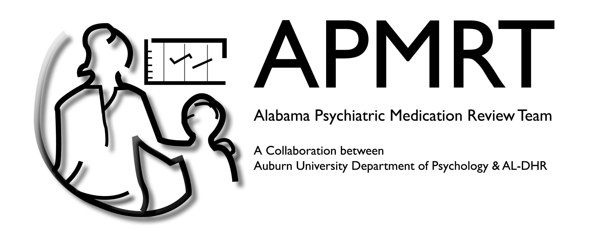
The Alabama Psychiatric Medication Review Team (APMRT) has developed a continuing education (CE) training package that will provide you with 1.5 CEs. This training package provides social workers with an overview of common medications as well as prepares case workers for appointments with prescribers. After completing the training, APMRT will send you a completed certificate.

The training will take between 90 and 120 minutes and must be completed in one sitting.

Objectives:
- Learn to have effective appointments with prescribers
- Understand the uses of psychotropic medications commonly prescribed in foster care
- Understand potential side effects of psychotropic medications commonly prescribed in foster care
- Know how to respond if a foster child is experiencing side effects
- Be able to educate caregivers on basic information related to psychotropic medications
- Know where to direct caregivers if they have any questions related to psychotropic medications

Instructions

- Click the following link: https://auburn.qualtrics.com/jfe/form/SV_8CH19NnlOtM5Jkx
- Once directed to the training package, follow the instructions on the screen.
- After each of the seven sections, you will be asked 5 questions.
- You must score 80% (4/5 questions correct) in order to pass that section.
  - If you pass: you will be directed to the next training section.
  - If you do not pass: you will be directed to restart the training section.
- Once you have passed ALL seven training sections, you will be prompted to enter your social worker license number.
- You will receive your continuing education as soon as APMRT processes the information.
- If you have any questions, please contact us by following this link: https://cla.auburn.edu/apmrt/contact/

Thank you for collaborating with us!

